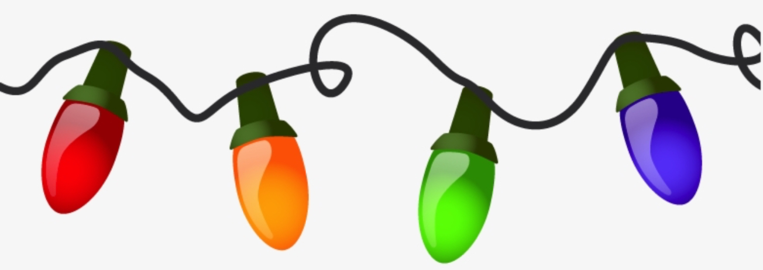

Light Up Southgate!

The Park and Tree Board invites all Southgate residents to light up their homes to participate in the Christmas Home Awards!
Turn your lights on from 7 PM to 9 PM starting Monday, December 11 for a chance to win a prize in one of the following categories:
Classic Christmas - a pretty look that reminds everyone of Christmas
Toyland Christmas - a look that reminds everyone of a children’s Christmas
Fantasyland Christmas - shows creativity and imagination
Multi-family Home - for multi-family homes, apartments, and condos, a festive display that shows an eye for design
Awards will be announced and winners will be contacted on Saturday, December 16. Prizes will be awarded at the Southgate Community Christmas Party on Sunday, December 17 starting at 2 PM at the Community Center.
Help light up Southgate and be sure to enjoy the many beautiful displays celebrating the season!

