BOOK BUS SUMMER PARKS TOUR
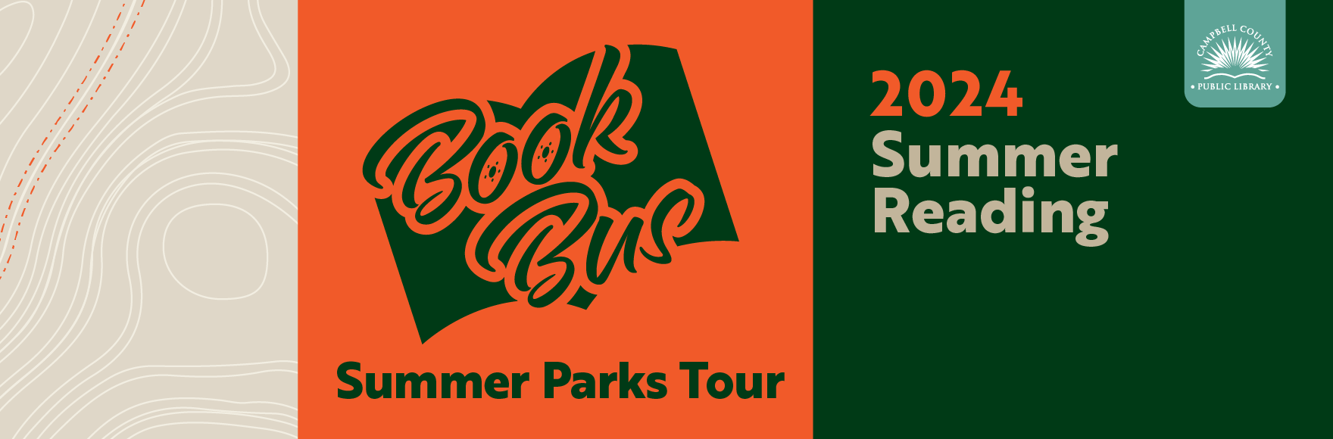
The Book Bus is hitting the roads of Campbell County this June & July to bring summer fun to a park near you.
All events start at 10 am. No registration is required. In case of inclement weather, check out the library’s website or call any of our branches.
Families can bring their own blankets and chairs as seating. Climb aboard the Book Bus and pick out a free book to keep.

